PRESS RELEASE

A dream job for young animal lovers: “My Pet School 3D” for the Nintendo 3DS system
Players help animal owners in training their darling pets. In the new development and care simulation from TREVA Entertainment in the Nintendo eShop on the Nintendo 3DS they can teach four-legged friends and birds amusing tricks and prepare them for important examinations, so they can become proud and faithful companions, whether as a guide dog or a film star.
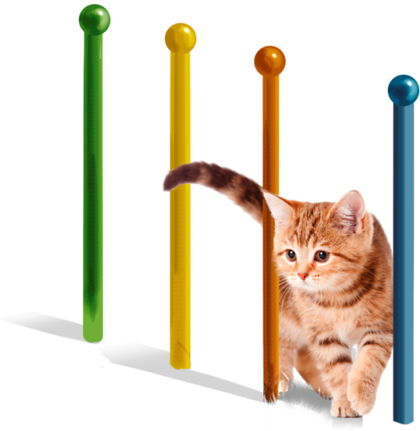
Hamburg, 26th March 2015 – A classroom for four-legged friends is the latest title from TREVA Entertainment GmbH. “My Pet School 3D” for Nintendo 3DS serves up exciting tasks for animal loving children. They start out on a great career, running their own animal school and training cute dogs, cats, rabbits, mice, horses and parrots. Even playful puppies and cute kittens are cared for in special enclosures. Plenty of patience and knowledge is needed in order to train the animals.
At the outset it’s all about giving simple commands and performing little tricks: holding out a paw, lying down, sit up and beg, turning in circles. The animals receive strokes and snacks as a reward. The animal trainers have to constantly monitor their animals’ stats – learning progress, energy, confidence, hunger and hygiene – and see to it that they don’t want for anything. The stores in the nearby town provide opportunities for players to buy new care and training accessories as well as food for their animals. Both humans and animals can relax by going walkies in the countryside or taking a ride-out on horseback around the forested lake. As the game progresses, the animal school can be steadily expanded and its pupils prepared for more complex tasks. There are special exercises in which they can be trained in road safety, as a family pet, as a guide or sniffer dog. Particularly gifted animals can make their star debut on lots of differently styled film sets.
The animal trainers learn as they go too. They will find out lots about their favourite animals and can apply their knowledge in the classroom.
“My Pet School 3D” supports the Nintendo 3DS Circle Pad control. Play Coins can also be collected and exchanged for in-game currency.

Key Features
- Numerous popular animal varieties and even their babies too
- Extensive game area in a colourful 3D world: animal school with large grounds, go walkies and on ride-outs by the forested lake, opportunities to go shopping in the town.
- Playful animal training: teach fun tricks and actions
- Special exercises for training the animals (e.g. road safety, guide dog, movie role)
- Rewards for the animals in the form of strokes and treats.
- Development and expansion of the animal school
- Circle Pad support
- Collect Play Coins

“My Pet School 3D” is available right now in the Nintendo eShop for Nintendo 3DS at $ 19.99.

My Pet School 3D

Platform: Nintendo 3DSTM
Genre: 3D Pet Care and Training Simulation
Target Group: Kids 7+
Price: $ 19,99
Release: March 26th, 2015
Age Rating: E (Everyone)
Publisher: TREVA Entertainment GmbH
Developer: Raylight Studios
Languages: English, French, Spanish

Images and further information about our titles can be found on our media server:
URL: http://www.treva-entertainment.com/english/press/press-server/

About TREVA Entertainment:
TREVA Entertainment GmbH launched in 2006. The Hamburg based company publishes cool, fresh child, youth and family themed titles for console, PC, online and mobile platforms.
At the heart of the TREVA portfolio are the internationally established own series labels, ‘Horse & Foal, ‘ANIKIDS’, ‘Classics To Go’ and ‘J4G – JUST FOR GIRLS’. Also, standalone titles like ‘Just SING!’, the world’s ﬁrst ever karaoke games for the Nintendo DSi™ and ‘Dance! It’s your Stage’ featuring Detlef D! Soost belong to its core business. In addition, selected strong international licenses such as ‘Emily the Strange™’ and ‘America’s Next Top Model™’ complete the publisher’s offer.

Press Contact
Katrin Haase
TREVA Entertainment GmbH
Goldbekplatz 3-5
D-22303 Hamburg, GERMANY
Phone: +49 - 40 / 22 63 633-60
Fax: +49 -40 / 22 63 633-33
E-Mail: k.haase@treva-entertainment.com
Website: www.treva-entertainment.com

