PRESS RELEASE

Saddle up and play: “Best Friends – My Horse 3D”
Horse fans, big and small, will certainly enjoy the new Nintendo 3DSTM game from TREVA Entertainment in the Nintendo eShop: they look after their favourite animals and win exciting tournaments together.
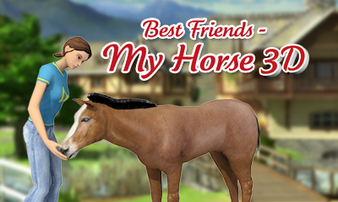
Hamburg, 26th March 2015 – Friendship is the central theme in “Best Friends – My Horse 3D” now being published by TREVA Entertainment GmbH for the Nintendo 3DS. In this horse care and riding simulation players build close relationships with their horses and stay with them through thick and thin.

Choosing from a wide range of warm, cold and full blood horses such as Arabian, Friesian or Freiberger, players are able to create their dream horses. There is a shop full of useful equipment for both horse and rider, a wide selection of saddles, blankets, bridles and brushes as well as chic riding apparel. A comprehensive care program awaits in the stables and therapy house: grooming, massage, showering, scraping out hooves and plenty more.

But “Best Friends – My Horse 3D” is not only about looking after horses, riding them is important too. Ten show jumping courses of varying difficulty are available to the young horse fans. The Nintendo 3DS tilt and Circle Pad controls make riding big fun: you have to wait for just the right moment to carry out the commands and tilt the Nintendo 3DS in the desired direction. With a little bit of practice, a well-coordinated team can soon start to take part in tournaments. However, while doing this, our equine enthusiasts should always keep an eye on the values of trust, hunger and hygiene. Adorned with pretty accessories, the dream team may even win one of the numerous beauty contests.
Furthermore, using the Nintendo 3DS StreetPassTM function cute foals can be reared and trained using a lunge line – motivated by carrots harvested by the players themselves!
“Best Friends – My Horse 3D” offers even more Nintendo 3DS functions: along with the 3D view these are the Circle Pad support as well as the ability to obtain support in completing tasks using collected Play Coins.
Your horses and you – best friends forever!

Key Features
- Comprehensive Nintendo 3DS features:
  - Richly detailed 3D view
  - Tilt and circle pad controls when riding
  - StreetPass: breed cute foals
  - collect Play Coins
- Large choice of horse breeds from which to create own dream horse
- Interaction with the horses: feeding, caring, ornamenting and riding the horse
- 10 show jumping courses offering increasing challenges
- Shop for riding equipment, clothing and accessories

“Best Friends – My Horse 3D” is available right now for the Nintendo 3DS at € 29.99 in the Nintendo eShop. To visit the virtual marketplace, players should look in ‘System Settings’ for an ‘Access Point’ in their locality and then use this to make an Internet connection. The game can then be easily downloaded from any location.

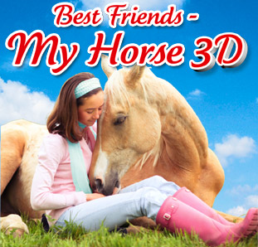
Best Friends – My Horse 3D

Platform: Nintendo eShop for Nintendo 3DSTM
Genre: 3D horse care and riding simulation
Target Group: Girls 7+
Price: € 29,99
Release: March 26, 2015
Age Rating: USK 0 / PEGI 3
Publisher: TREVA Entertainment GmbH
Developer: Independent Arts Software
Languages: English, German, Italian

Images and further information about our titles can be found on our media server:
URL: http://www.treva-entertainment.com/english/press/press-server/

Nintendo DSi and Nintendo 3DS are trademarks of Nintendo. © 2011 Nintendo.

About TREVA Entertainment:
TREVA Entertainment GmbH launched in 2006. The Hamburg based company publishes cool, fresh child, youth and family themed titles for console, PC, online and mobile platforms.
At the heart of the TREVA portfolio are the internationally established own series labels, ‘Horse & Foal, ‘ANIKIDS’, ‘Classics To Go’ and ‘J4G – JUST FOR GIRLS’. Also, standalone titles like ‘Just SING!’, the world’s ﬁrst ever karaoke games for the Nintendo DSi™ and ‘Dance! It’s your Stage’ featuring Detlef D! Soost belong to its core business. In addition, selected strong international licenses such as ‘Emily the Strange™’ and ‘America’s Next Top Model™’ complete the publisher’s offer.

Press Contact
Katrin Haase
TREVA Entertainment GmbH
Goldbekplatz 3-5
D-22303 Hamburg, GERMANY
Phone: +49 - 40 / 22 63 633-60
Fax: +49 -40 / 22 63 633-33
E-Mail: k.haase@treva-entertainment.com
Website: www.treva-entertainment.com

