PRESS RELEASE

The glittering world of fashion on the Nintendo 3DSTM: “Top Model 3D”
The fashion model simulation from TREVA Entertainment for the Nintendo eShop on Nintendo 3DS lets young girl players see if they have the talent and ambition to become an internationally successful supermodel.

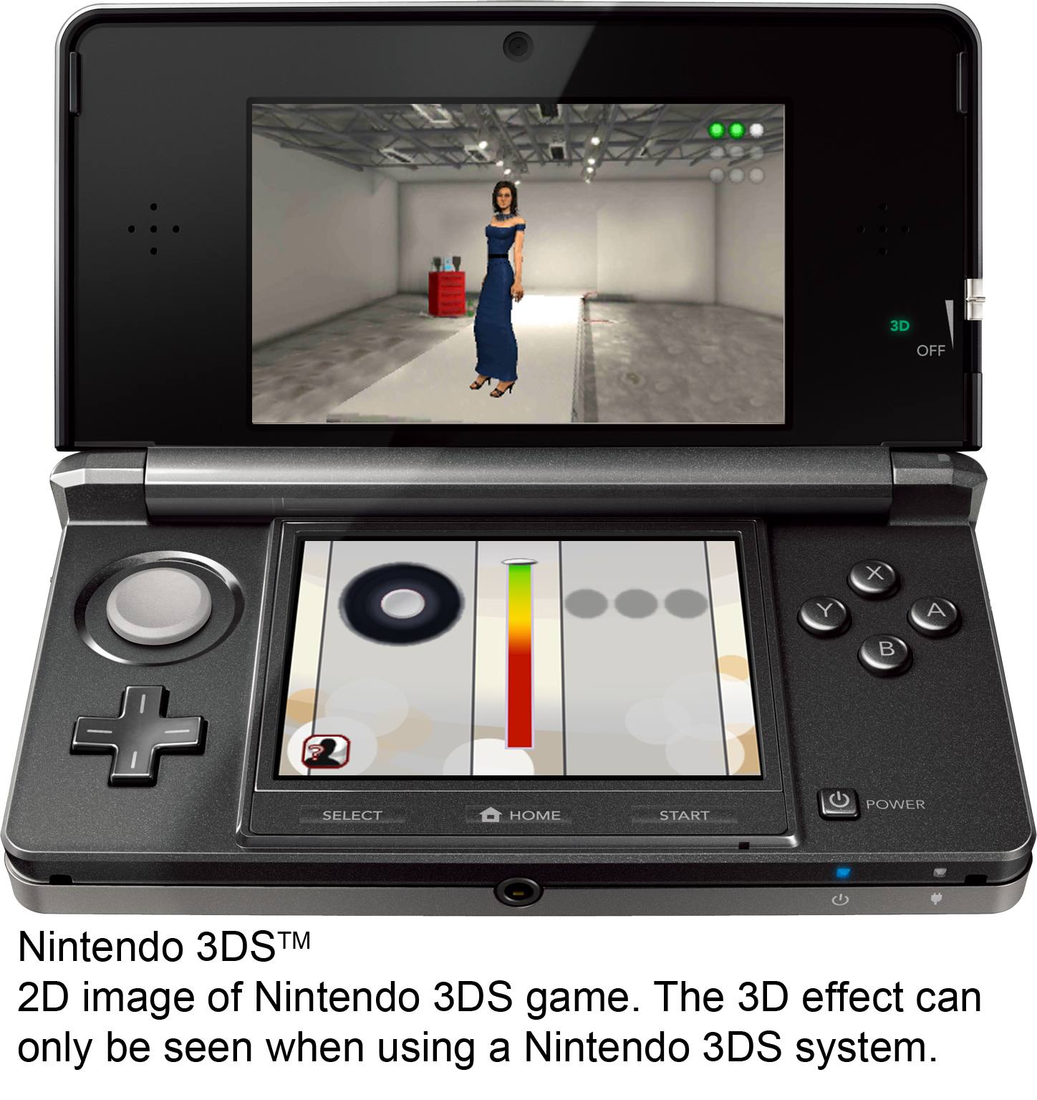
Hamburg, 11th September 2014 – “Top Model 3D” for the Nintendo 3DS is the latest release from the house of TREVA Entertainment GmbH. Players can follow in the footsteps of the world’s supermodels and conquer the modelling catwalk.
Ten top models have come together at the beginning of the game and the player is one of these. Each one of them has the same goal: in the coming 10 weeks, they all want to win round after round in order to become the fabulous winner of the modelling contest.
The candidates share a trendy loft apartment, but every week one of the girls will have to leave it. They have to put their skills on show in front of the jury and make sure it’s their talent on the catwalk that wins the panel over. Rigorous training is needed to fulfill the weeks’ tasks, but a there’s a coach on hand with useful tips to overcome these challenges.The top model conquers the catwalk and poses elegantly at photo shoots in loads of cool locations demonstrating their cool style at every opportunity. Even putting on make-up is a part of the daily routine, as is organising their own appointments.
At the end of every week comes the strut down the catwalk in front of the jury. Will our star model receive a photo to take her into the next round, or will she be asked to leave? The jury decides! The panel also asks questions about the glamorous modelling business – those who know their stuff on the subject can collect plus points and impress the jury.
“Top Model 3D” supports the Circle Pad control for posing at the photo shoots. Players can use the Nintendo 3DS camera to take a real 3D photo of themselves and use it in the game. Collected Play Coins can be used in order to indulge in a relaxing wellness day.
Key Features
- The glamorous modelling world in stereoscopic 3D: Luxurious apartment, cool locations for photo shoots etc.
- Mini-games around the modelling theme: Catwalk, Make-up, Fashion, Photo Shoots
- Weekly planning using a PDA
- Answering the modelling business questions correctly, increases chances of winning
- Circle Pad controls supported
- Make a 3D photo of yourself and use it in the game
- Collect Play Coins and exchange them for a spa day

“Top Model 3D” is available right now for the Nintendo 3DS at $ 19.99 in the Nintendo eShop.


Top Model 3D
Platform: Nintendo eShop for Nintendo 3DSTM
Genre: Model Simulation
Target Group: Girls 7+, young women
Price: $ 19.99
Release: September, 11th, 2014
Age Rating: E (Everyone)
Publisher: TREVA Entertainment GmbH
Developer: Independent Arts Software
Languages: EN, DE, ES, FR, IT, NL

Images and further information about our titles can be found on our media server:
URL: www.treva-entertainment.com/english/press/press-server/

About TREVA Entertainment:
TREVA Entertainment GmbH launched in 2006. The Hamburg based company publishes cool, fresh child, youth and family themed titles for console, PC, online and mobile platforms.
At the heart of the TREVA portfolio are the internationally established own series labels, ‘Horse & Foal, ‘ANIKIDS’, ‘Classics To Go’ and ‘J4G – JUST FOR GIRLS’. Also, standalone titles like ‘Just SING!’, the world’s ﬁrst ever karaoke games for the Nintendo DSi™ and ‘Dance! It’s your Stage’ featuring Detlef D! Soost belong to its core business. In addition, selected strong international licenses such as ‘Emily the Strange™’ and ‘America’s Next Top Model™’ complete the publisher’s offer.

Press Contact
Katrin Haase
TREVA Entertainment GmbH
Goldbekplatz 3-5
D-22303 Hamburg, GERMANY
Phone: +49 - 40 / 22 63 633-60
Fax: +49 -40 / 22 63 633-33
E-Mail: k.haase@treva-entertainment.com
Website: www.treva-entertainment.com

