PRESS RELEASE

Horse breeding on the Nintendo 3DSTM: “Life with Horses 3D”
TREVA Entertainment publishes “Life with Horses 3D” in the Nintendo eShop on the Nintendo 3DS hand-held system. In the game players renovate their own riding stables, look after their personal horse and care for cute little foals. Together with ride-outs, stable work and horse care, all kinds of strategic decision-making await our young equestrian fans.
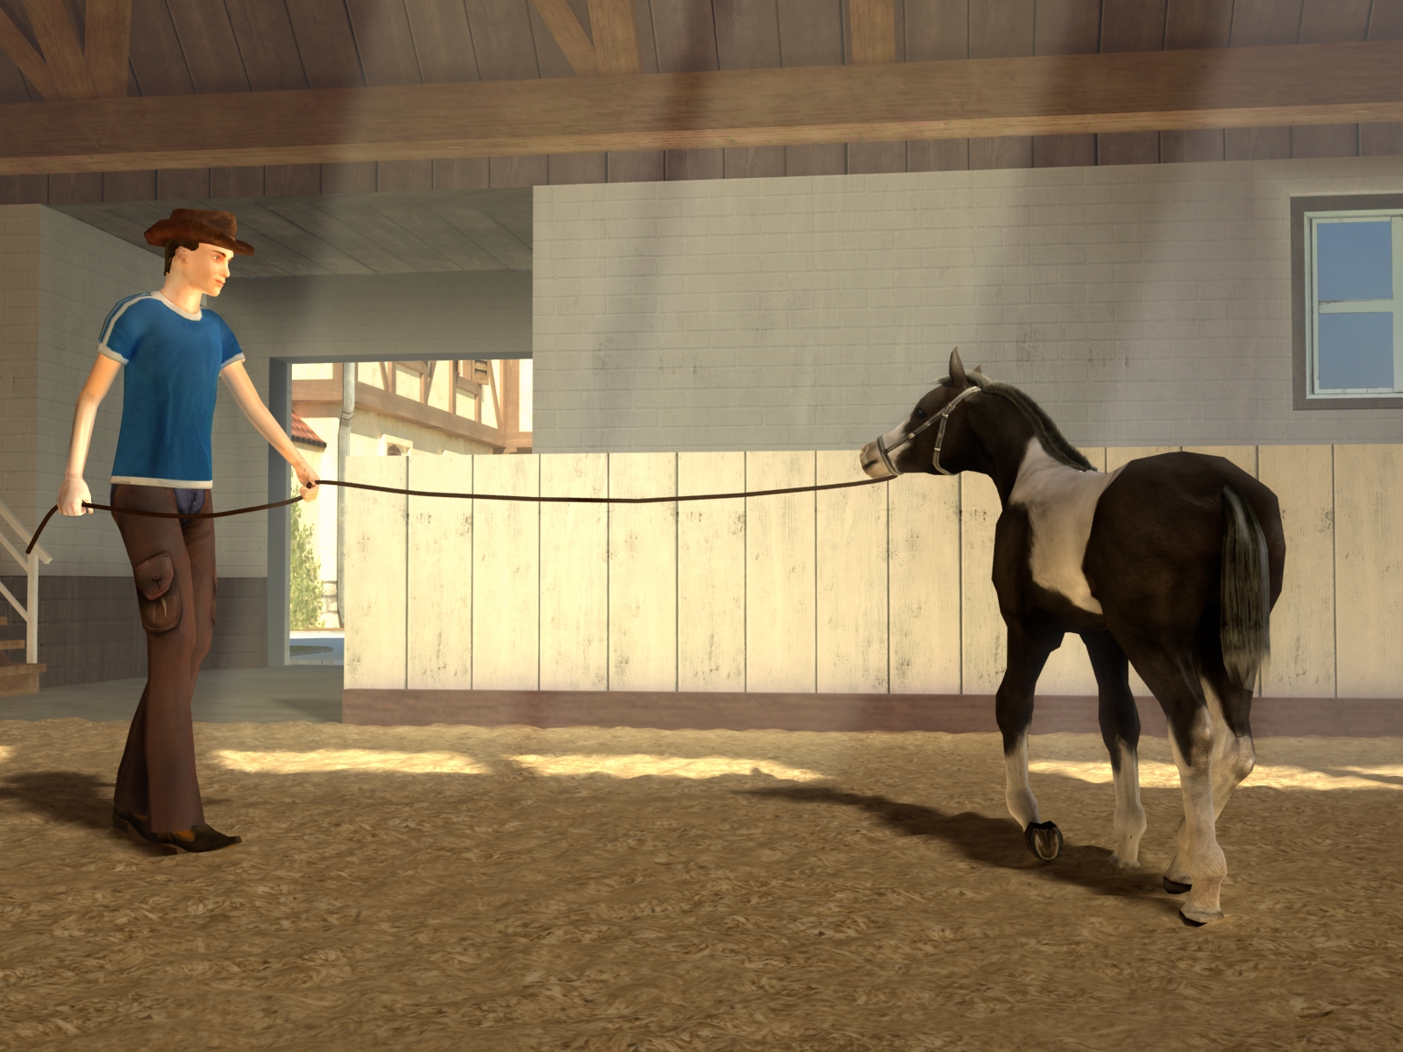
Hamburg, 12th December 2013 – In “Life with Horses 3D” TREVA Entertainment appoints the player as the proud owner of a run-down stud farm. This is where she is set the task of bringing the dilapidated farmstead back into tiptop condition.
In the course of the game the riding hall, stalls and the guesthouse are renovated in order to attract enthusiastic guests. Because a satisfied clientele is happy to pay for its stay and with more income, the more the stud can be expanded. Thus a new breeding stall gets built, and shortly after that there’s the stud’s first new edition, frolicking in the meadow.
The foals are trained on a lunge line and can be sold to trusted buyers. In addition to this the stud can become ever larger and more popular through its accommodation business along with horse breeding and competing successfully in tournaments. And more and more guests arrive to take up the player’s offers.
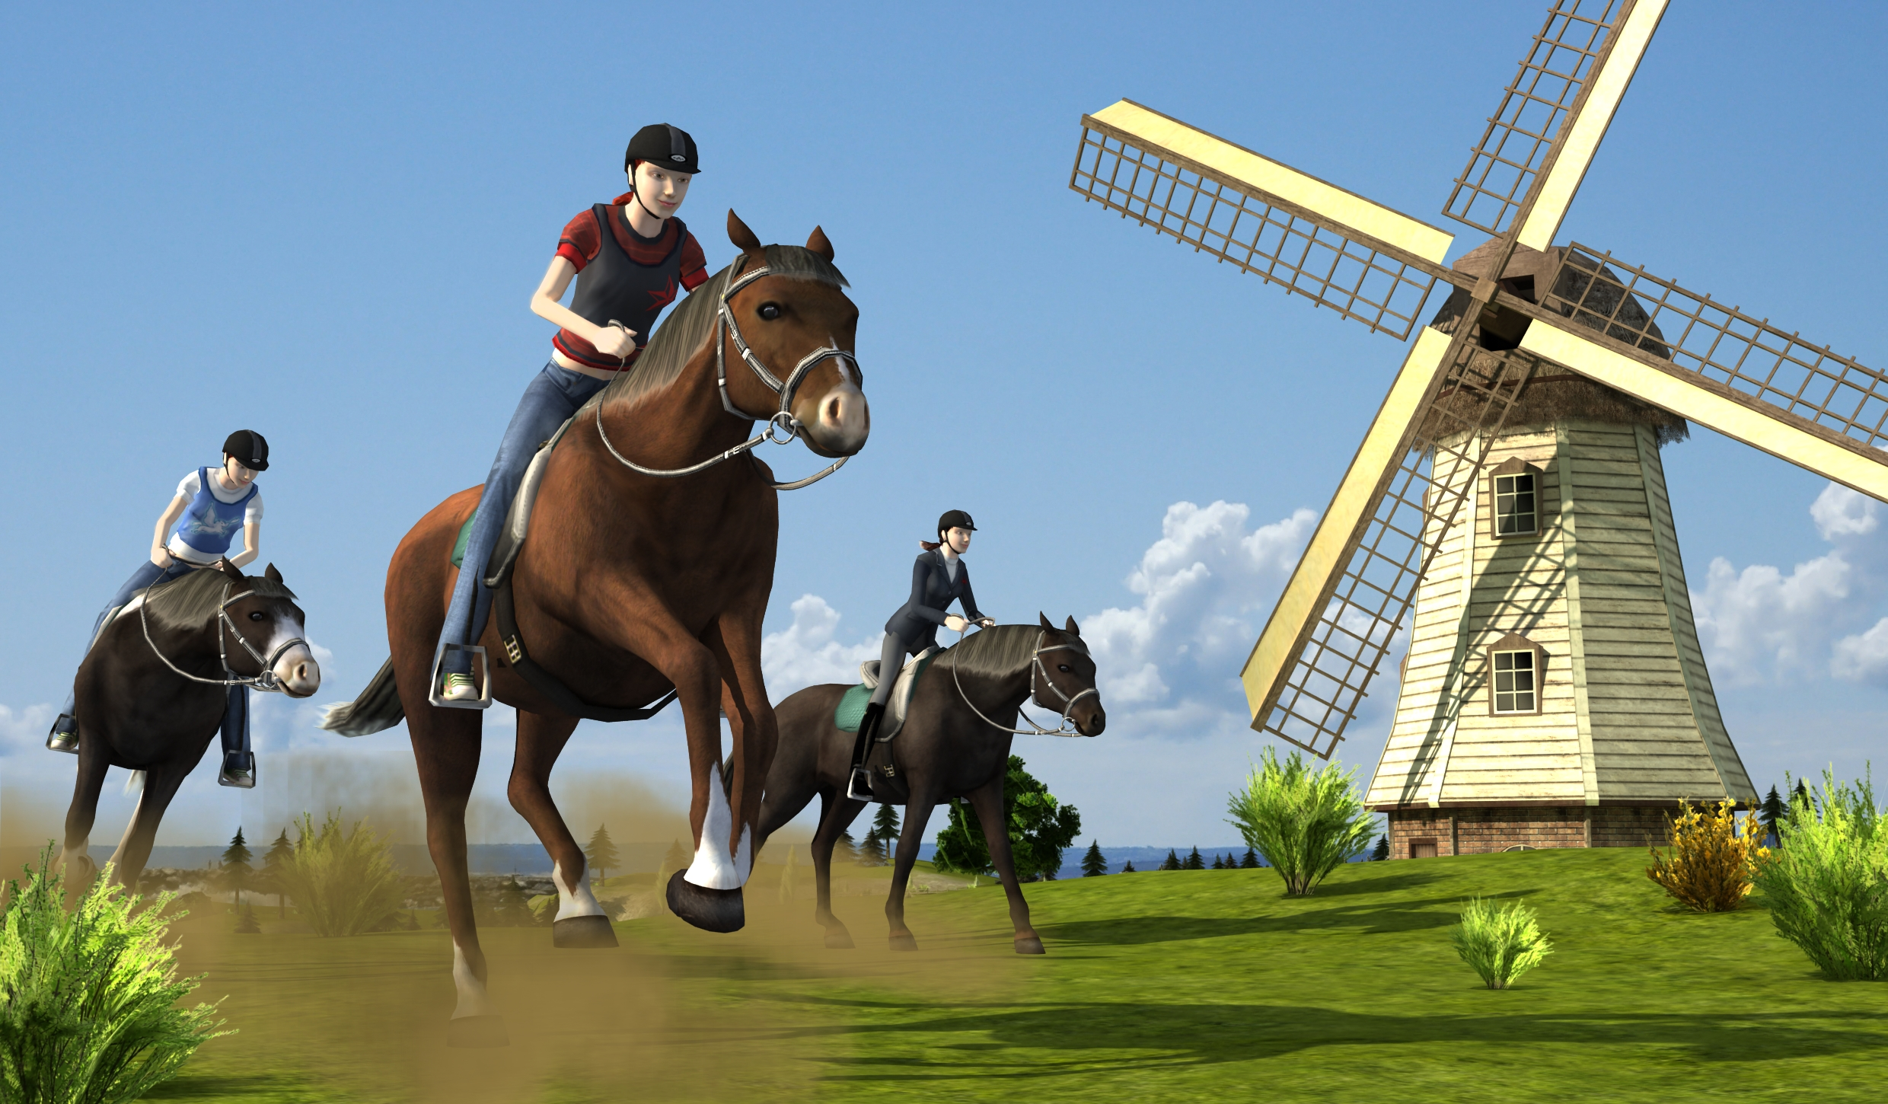
But along with all this engagement, there is also still time for the young horse breeder to have some fun of her own. She can take her horse for extended ride-outs in the country, or can train for exciting cross country races on the stud’s racecourses. Using the interactive Nintendo 3DS controls and the stunning 3D graphics, the rider gets close up to experiencing what it’s like to ride at full gallop and master some awesome jumps.
A very special extra: if the player meets other players in StreetPassTM mode, then the horse values rise and makes breeding cute foals possible.

Key Features
- Realistic Nintendo 3DS tilt and movement controls during ride-outs, showering and foal training.
- StreetPass: Meeting other players increases horse values and enables foal breeding.
- Collected Nintendo 3DS Play Coins can be exchanged for the immediate mastering of mini games.
- Varied selection of mini games such as massage, lunge line training and grooming.
- Breeding of own foals with more than 100 possible combinations.
- Exciting cross country races through wonderful countryside.
- Comprehensive business component with the aim of running the best stud farm in the world.

“Life with Horses 3D” is available right now at $29.99 in the Nintendo eShop on Nintendo 3DS, the virtual destination for all digital content.
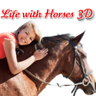
Life with Horses 3D
Platform: Nintendo eShop for Nintendo 3DSTM
Genre: Horse simulation
Target Group: Children 6+
Price: $ 29.99
Release: December 12, 2013
USK/PEGI: 0 /3
Publisher: TREVA Entertainment GmbH
Developer: Independent Arts Software

Images and further information about our titles can be found on our media server:
URL: www.treva-entertainment.com/english/press/press-server/

Nintendo DSi and Nintendo 3DS are trademarks of Nintendo. © 2011 Nintendo.

About TREVA Entertainment:
TREVA Entertainment GmbH launched in 2006. The Hamburg based company publishes cool, fresh child, youth and family themed titles for console, PC, online and mobile platforms.
At the heart of the TREVA portfolio are the internationally established own series labels, ‘Horse & Foal, ‘ANIKIDS’, ‘Classics To Go’ and ‘J4G – JUST FOR GIRLS’. Also, standalone titles like ‘Just SING!’, the world’s ﬁrst ever karaoke games for the Nintendo DSi™ and ‘Dance! It’s your Stage’ featuring Detlef D! Soost belong to its core business. In addition, selected strong international licenses such as ‘Emily the Strange™’ and ‘America’s Next Top Model™’ complete the publisher’s offer.

Press Contact
Katrin Haase
TREVA Entertainment GmbH
Goldbekplatz 3-5
D-22303 Hamburg, GERMANY
Phone: +49 - 40 / 22 63 633-60
Fax: +49 -40 / 22 63 633-33
E-Mail: k.haase@treva-entertainment.com
Website: www.treva-entertainment.com

