PRESS RELEASE
Dreambear Saga: Trick or treat!
The arrival of the Headless Horsebear at the free browser game “Dreambear Saga” announces the dawn of Halloween. He has numerous scary costumes and an extraordinary quest for the players.

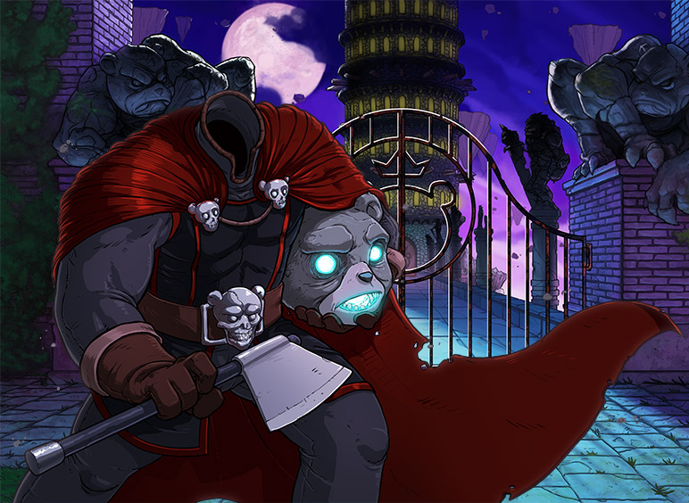
Hamburg, October 25th, 2012 – Strange things are happening in the free browser game „Dreambear Saga“. One week before Halloween a mysterious Headless Horsebear has appeared at The Growl Gate. With his head in his hand, he is sitting on dangerously luminescent pumpkins and waiting. What is he up to? Everybody who is brave enough to talk to him will realize that he is good-hearted. His biggest wish is to go and collect candy corn and caramel apples. Unfortunately, his headless appearance is so scary that no bear wants to offer him a single treat. Now it is up to the players to try their luck and collect delicious sweets. Their first place to go is the Candy Brothers’ who are well-known for their sweet titbits. These days they offer lots of pumpkins and ghost candies. When asked friendly, they will happily share some of their sweets. The enchanting Salah, Tyler and Lady Zartanna are generous as well. The players will soon have a respectable yield available. Overwhelmed by the amount of candies, the Headless Horsebear will give a tremendously eerie pumpkinhead to the players, so they can scare all the other bears of Beronia at Halloween.
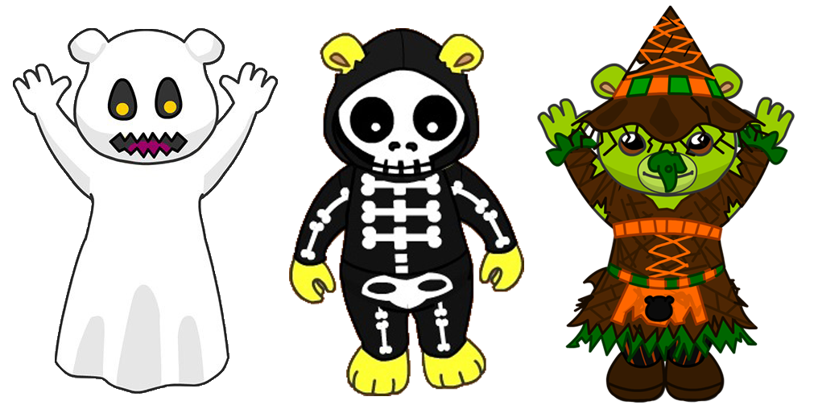
Those who want some more creepy outfits can buy them from the Headless Horsebear. He offers spooky ghost, skeleton, witch costumes and many more.
The scary visitor will stay in Beronia until November 7th. Everybody who doesn’t want to miss him can register at www.dreambearsaga.com without charge and play the online game for free.

Images and further information about our titles can be found on our media server: www.dtp-young.com/presse

About Dreambear Saga:
Dreambear Saga is a free online flash game. Surrounded by a fairytale-like world with hand-painted graphics, the players become Dreambears and explore the idyllic Beronia. The future of the country is threatened by prince Growl who wants to conquer the throne. The gamers avert his plans by solving numerous challenges such as amusing mini games and exciting daily missions.
Social interactions play an important role: Players will meet (can meet klingt irgendwie so nach “vielleicht” ☺) new friends, chat with them and solve tasks together.
Dreambear Saga was developed by the Dutch company WEBER Sites & Games BV.

About dtp young entertainment:
dtp young entertainment GmbH started work in 2006. The Hamburg based company publishes trendy child, youth and family themed titles for console, PC, online and mobile platforms.
At the heart of the dtp young portfolio are the internationally established own series labels, ‘Horse & Foal, ‘ANIKIDS’, ‘Classics To Go’ and ‘J4G – JUST FOR GIRLS’. Also, standalone titles like ‘Just SING!’, the world’s ﬁrst ever karaoke games for the Nintendo DSi™ and ‘Dance! It’s your Stage’ featuring Detlef D! Soost belongs to its core business. In addition, selected strong international licenses such as ‘Emily the Strange™’ and ‘America’s Next Top Model™’ complete the publisher’s offer.

Press contact
Sofie Dittmer
PR Manager

dtp young entertainment GmbH
Goldbekplatz 3-5
D-22303 Hamburg
Phone: +49 - 40 / 22 63 633-80
Fax: +49 - 40 / 22 63 633-81
E-Mail: s.dittmer@dtp-young.com

