PRESS RELEASE
”Dreambear Saga” bids new inhabitants welcome
A strange professor, a flower loving painter and a saleswoman with a hero costume – these are the new inhabitants of the free online game “Dreambear Saga”. They took up residence at a new discovered place.

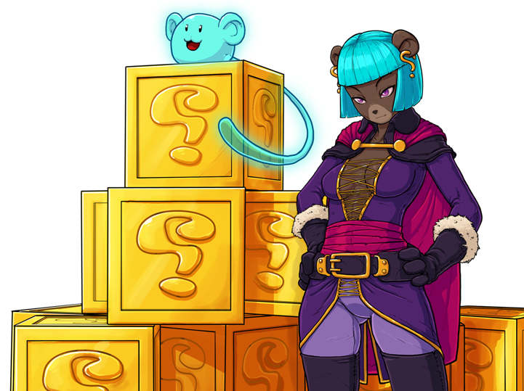
Hamburg, October 16th, 2012 – The impressive kingdom Beronia in the free browsergame “Dreambear Saga” is growing and gets a new place of interest: “The Mystery Corner”. The small, sedate place is located between the “Sunset Arena” and “The Job Board”. Three strangers are waiting there to get to know the bear community. One of them is the odd professor Michikaku. He loves to observe the stars while he cultivates the weirdest plants. Right next to him the players meet the talented Thomas van Gogh. He paints as much pictures as he can in order to become a famous painter during his lifetime. The biggest passion of the bear with the big hat are yellow sunflowers. The third one is the fascinating Lady Zartanna. Her shiny blue hair attracts everyone’s attention. From a distant world she made her way to Beronia and took mysterious boxes with her, which contain great surprises.
To be able to sell her Mystery Boxes, she needs help from the players. The task: They have to go to the Dreamcouncil and ask for a trading permission. Before the council can make its decision, it wants proof of Zartanna’s trustworthiness. Three honest bears shall confirm her reliability. Therefore, the players visit Sally, the owner of the pet store, Captain Crowbar and Crystal Icecap.
Everyone, who wants to know, if Lady Zartanna will get her important license in the end, can register for free at www.dreambearsaga.com and play the online game for free.

Images and further information about our titles can be found on our media server: www.dtp-young.com/presse

About Dreambear Saga:
Dreambear Saga is a free online flash game. Surrounded by a fairytale-like world with hand-painted graphics the players become Dreambears and explore the idyllic Beronia. The future of the country is threatened by prince Growl, who wants to conquer the throne. The gamers avert his plans by solving numerous challenges like amusing mini games and exciting daily missions.
An important role play social interactions: Everybody can meet new friends, chat with them and solve tasks together.
Dreambear Saga was developed by the Dutch company WEBER Sites & Games BV.

About dtp young entertainment:
dtp young entertainment GmbH started work in 2006. The Hamburg based company publishes trendy child, youth and family themed titles for console, PC, online and mobile platforms.
At the heart of the dtp young portfolio are the internationally established own series labels, ‘Horse & Foal, ‘ANIKIDS’, ‘Classics To Go’ and ‘J4G – JUST FOR GIRLS’. Also, standalone titles like ‘Just SING!’, the world’s ﬁrst ever karaoke games for the Nintendo DSi™ and ‘Dance! It’s your Stage’ featuring Detlef D! Soost belongs to its core business. In addition, selected strong international licenses such as ‘Emily the Strange™’ and ‘America’s Next Top Model™’ complete the publisher’s offer.

Press contact
Sofie Dittmer
PR Manager

dtp young entertainment GmbH
Goldbekplatz 3-5
D-22303 Hamburg
Phone: +49 - 40 /22 63 633-80
Fax: +49 - 40 / 22 63 633-81
E-Mail: s.dittmer@dtp-young.com

